Feedback for Undergraduate Mathematics Students

Informed by students, written by students, created for students

Sophie Marshall
July 2023

Section 1: What is feedback & how should I use it? 2
Section 2: What feedback is available? 3
Tutorials, Supervisions, and Lectures 3
Written feedback on submitted work 3
General exam feedback and model solutions 4
Piazza 4
Office hours 6
Blackboard quizzes 6
Peers 6
PASS 7
ILOs and Syllabus 7
Other resources 8
Section 3: Problem-solving and active feedback through comparison 9
Do 10
Compare 11
Make explicit your comparisons 13
Section 4: How to make the most of office hours 14
Further resources 16
Welfare 16
Academic Malpractice 16

Section 1: What is feedback & how should I use it?
Feedback is any information that helps you to understand your progress. Although feedback is traditionally thought of as delivered by a teacher and received by a student, this is only a small aspect of what feedback really is. Feedback might indicate your strengths and weaknesses, what action you should take to improve, or give you an overall idea of how well you are doing.

At university, you are encouraged to take control of your learning and develop your ability to work and improve independently, as well as experiment with different methods of learning to find what works best for you. To facilitate this transition into a more independent style of learning, in first year you will receive lots of direct feedback from your teachers, most frequently in the form of weekly marks and written comments on your submitted problem sheet solutions. From second year onwards, usually your only opportunities to receive formal feedback in this way will be on your coursework, midterm tests, and final assessments.

During your first year, you should make the most of your written feedback while also familiarising yourself with other sources of feedback, which you will be more dependent on for the remainder of your degree. Your first year feedback is important not only for helping you within a particular module but also for helping you develop your ability to self-assess by giving you an idea of what is expected of you in terms of mathematical writing, notation, and logical argument.

As well as direct feedback, delivered to you by teaching staff, some other kinds of feedback which are available to you include inner or self-feedback, where by using available resources you can reflect and create feedback on your work for yourself, peer feedback, and other forms of collaborative, conversational feedback.

This guidance contains a lot of general advice and information about common practice but, in reality, every module is delivered differently and will have its own methods of assessment and feedback. Make sure that you read the relevant course-specific information carefully for details about assessment, feedback, weekly activities, office hours, supervisions, coursework, and so on. This information is usually found on Blackboard.

In a 2023 survey, we asked undergraduate UoM mathematics students to share their thoughts about the feedback available to them, what sort of feedback they use the most, and how they use it. The following guidance incorporates a wide variety of these responses to present you with lots of different ways to get feedback. Everyone learns differently, so you do not need to follow all the guidance here or use every single source of feedback exactly as suggested. We hope that the following guidance will give you some ideas about how to structure your learning and help you find the methods which work best for you.

Section 2: What feedback is available?

Your most essential sources of feedback are those which are embedded into the course. As you would expect, they all operate within a framework of you attempting problems and then reflecting on your solutions, with or without the help of staff, for next time. Unlike other supplementary feedback sources, you are strongly encouraged to make the most of all of the following core sources of feedback:

Tutorials, Supervisions, and Lectures
- In first year you will attend weekly supervision classes. Class sizes will start at around 12 students in semester 1 and increase to around 25 students in semester 2. In supervisions, you will review your submitted solutions with a supervisor as well as sometimes discuss further problems.
- From second year, instead of supervisions, you will attend tutorials. The only differences are that a tutorial class will normally be larger (they may go up to as many as 50 students), and you will usually not have to submit your solutions before the class nor will you receive marks or written feedback. However, a small number of courses in second year may still have weekly marked homework.
- In preparation for assessments, your lecturer may also choose to go over problems, past exam questions, or further examples in lectures.

Written feedback on submitted work, including weekly problem sheets and midterm tests/coursework.
- In first year, you will have to submit your solutions to certain questions on problem sheets, and your supervisor will give you written feedback as well as a mark for effort and engagement.
- Don’t be afraid to get questions wrong, since you can still get full marks as long as you give all the questions a good go. This is an excellent opportunity to make mistakes and get useful feedback about how to fix them, while not worrying about mistakes impacting your final grade.
- Your problem sheets will not be submitted or marked after first year, so you should make the most of this feedback while it lasts!
- You will also get feedback on your coursework/midterm test, depending on the form it takes. It might be a multiple-choice quiz on Blackboard, a take-home set of problems, or an in-class test. Either way, it will usually be one of your only opportunities to take a formative assessment, so you should pay special attention to the feedback you receive on it as it will help you prepare for your final assessments.

General exam feedback and model solutions to problem sheets, coursework, and past papers
- Your problem sheets will usually have model solutions to accompany them. Model solutions may be released a few days or weeks after the problem sheets to give you time to attempt the questions first.
- As well as your problem sheets, you will usually be provided with past papers to practise your problem-solving on. You can do these any time you like, but many students prefer to save them for just before final exams
- Not all modules will provide the model solutions/mark schemes to past papers for you to mark your work with, but most will. Some modules may provide you with general exam feedback as well as/instead of model solutions, which will comment on common errors and why solutions lost or were awarded marks.
- After taking a midterm test or submitting coursework, you may also be provided with model solutions or general feedback.
- For further advice on how to make the best use of model solutions, see Section 3: Problem-solving and active feedback through comparison

When you want more clarification or have unanswered questions, you will be able to supplement your core feedback via other sources. Not all of the following will be available for every course you take, but you will normally be able to get additional feedback through at least a few of these methods:

Piazza
- Piazza is the most common message board platform used by lecturers to communicate with students enrolled in their modules. If available, it is normally accessible from the module’s Blackboard page.
- Message boards can be very useful for quickly and easily getting answers to questions from home. Your lecturers will monitor the message board and answer your questions, but other students can communicate with each other as well.
- Posting on a message board has several benefits over emailing your lecturer. You can post your questions anonymously, so you don’t have to worry about asking “stupid questions” or looking silly. All students on a course can see the questions on the message board, so if anyone else has the same question as you, they can benefit from the answer as well.
- Before asking a question you can always search the message board and it may already have been answered.
- Some courses may use different platforms, but the main message board used by maths courses is Piazza. Here are some examples of how Piazza can be used. Names and the exact wording of questions and answers have been altered for anonymity, but these are real examples from a first year module’s Piazza page:
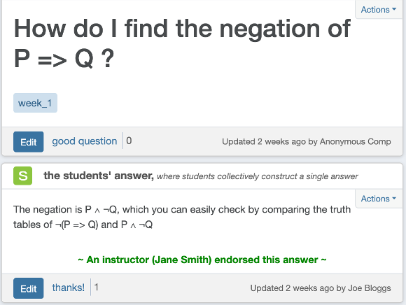

Here, note that the discussion has taken place only between students. Your lecturers will be able to monitor the message board, check that the advice students are giving each other is correct, and endorse helpful answers. The lecturer may choose to add to a student’s answer or answer the question themselves. For example:

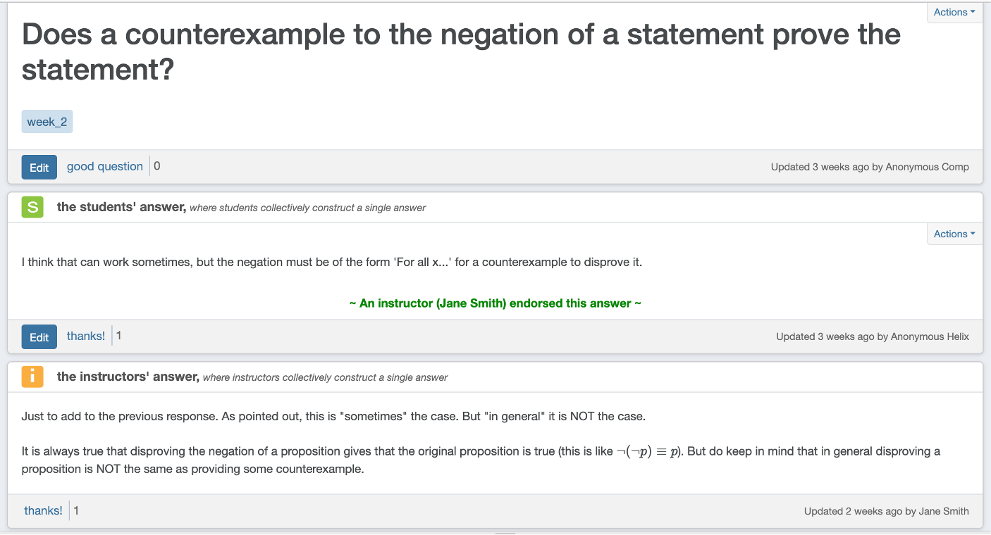

Also, note the possibility of posting questions anonymously. Some lecturers will make anonymity the default on their Piazza page, while others will let you choose whether you want to be anonymous to everyone, just your classmates or to display your name.

Office hours
- All your lecturers will have a dedicated weekly office hour where you can go to their office for a conversation. Some lecturers may also give the option of meeting over Zoom during their office hour.
- Office hours are a great opportunity to discuss a topic or a question in more depth than in a classroom setting or via email or message board, as well as get some feedback on your work.
- Lecturers are always happy to give feedback and help where you don’t understand something. However, you should come prepared to office hours: make sure that you have already made use of the available feedback and resources, caught up on lectures, and identified what questions you want to ask or topics you want to discuss.
- See Section 4: Office Hours for more guidance about how to make the most of office hours.

Blackboard quizzes
- Some of your courses may have not-for-credit quizzes available on Blackboard, often corresponding to weekly topics.
- Blackboard quizzes are great for testing your low-level understanding of the ILOs, such as recall and simple application of definitions. They are not a substitute for the problem sheets since they will only test a surface-level understanding, but they are a brilliant tool for reinforcing the basics when you are going over (or revisiting) a topic.
- Only a few courses have Blackboard quizzes. However, where they are available they are an easy and convenient source of feedback on your understanding of the basics.

Peers
- Your fellow mathematics students are one of your most invaluable learning resources during your degree.
- Discussing topics with other students on your course can help you to deepen your understanding, see a new perspective and identify gaps in your knowledge.
- You can give and receive feedback on written work with your peers, as well as compare and discuss your different answers. See Section 3: Problem-solving and active feedback through comparison for more detailed advice on how to feedback on your work through comparison.
- While collaboration with your peers can be very useful in the run-up to assessments, it is very important to note that assessed work should be done alone. Collaboration during assessments is academic malpractice (except where explicitly stated otherwise, such as in group projects), and can have very serious consequences.
- It can be hard to find peers on your course to work with, especially at the start of first year when socialising can be intense and intimidating. Remember that everyone is in the same boat trying to find friends and study groups at the start of university! Some ways to find other maths students to collaborate with are:
  - Welcome week activities
  - Supervision classes
  - Lectures
  - How To Study Maths sessions
  - PASS
  - MathSoc
  - Maths Club: hosted by MathSoc on Wednesdays from 1pm in the Alan Turing Building
  - Maths Sports Teams (organised by MathSoc): Join maths football or maths netball and compete against teams from other subjects!
  - The UoM Maths Discord Server has dedicated channels to connect students by year group and module and, among other fun activities and competitions, has successfully facilitated in-person study sessions before.
  - Other societies related to maths:
    - UoMDSS: Data Science Society
    - UMAS: Actuarial Science Society
    - WISE: Women in Science and Engineering Society
  - MIMUC (Manchester Interdisciplinary Mathematics Undergraduate Conference) runs yearly, usually around March, as a collaboration of Maths Department staff with societies (MathSoc, UOMDSS, and UMAS)
  - Social media (e.g. Facebook groups, MathSoc Instagram, WhatsApp year group/course chats, etc.)

PASS (Peer Assisted Study Sessions)
- As part of the PASS scheme, first year students will be put into small groups and assigned a PASS Leader, who will be a second or third year student. You will meet weekly to collaborate on problems and help each other with the guidance of a more experienced student.
- You may be working together on homework problems, discussing your understanding of difficult topics, or sharing different approaches.
- This is a great opportunity for discussion and conversational feedback and can be a less intimidating environment to discuss problems than with staff in office hours. Giving and getting feedback from your peers helps you to self-evaluate your learning and see how you can improve.

ILOs and Syllabus
- Every course has a list of Intended Learning Outcomes (ILOs), which describe what you should be able to do by the end of the course and what skills you can be assessed on.
- Assessments are always designed relative to the ILOs. According to university guidelines, assessments may only assess the ILOs, and students must have the opportunity to demonstrate their achievement of all the ILOs before the end of the course. On mark schemes of past papers, you will often see questions labelled with the ILO they are designed to assess, and at which level (low, medium, high).
- The ILOs are different from the course syllabus, which lists the mathematical content that you will learn about in the course.
- The ILOs and syllabus can therefore be used together as a checklist to prepare for assessments, most importantly as a reference to compare yourself against when self-evaluating and generating feedback for yourself.

Other resources. Some examples of resources that other students have said they often find helpful include:
- Textbooks: Your modules may have a suggested textbook which may be available online or in the library. Textbooks can be great for further explanation of topics and often contain extra questions for you to practise on and generate feedback. If the module has no official textbook associated, normally your lecturers will be happy to give you recommendations.
- YouTube: Explanations of many of the topics you study can be found in YouTube videos from both UoM and non-UoM affiliated contributors. These can be incredibly helpful but remain aware of the possibility of inaccuracies or subtle differences in the material being covered.
- Other online resources: There is a huge amount of resources available online which can assist you in your studies and help you to generate feedback on your work. All of these should be used with caution as they may contain errors or contain content that differs from your course. Some examples include:
  - Maths forums such as StackExchange, which is public and monitored by academics.
  - Publicly available materials from other universities such as lecture notes from similar courses.
  - Online calculators/solvers such as Symbolab or Desmos.
- Generative AI (Such as ChatGPT): You may be able to use AI to help you, but even more than any other online resource, you must be especially cautious. AI is not mathematically knowledgeable or logical, but a predictive language model. Make sure you always take AI-generated maths with a pinch of salt and are vigilant to check for mistakes. Furthermore, make sure that you are only using AI to support your learning as you would with any other tool which can help you at home but will not be available in an exam.

Section 3: Problem-solving and active feedback through comparison

The problems you will be set at university can be quite different from the sorts of problems you might be used to from school or college. They are designed to be challenging and develop your ability to solve problems, reason mathematically, and develop a deep understanding of the content you are taught. This section contains advice for tackling problem-solving at university, followed by a method of generating feedback on your own work through comparison, a process called Active Feedback (Jennifer Rose). Active feedback consists of three steps: Do, Compare, and Make Explicit. The idea is that you complete a piece of work, compare it to something (like a peer’s work or a model solution), and then make explicit your comparisons by answering some comparative questions.
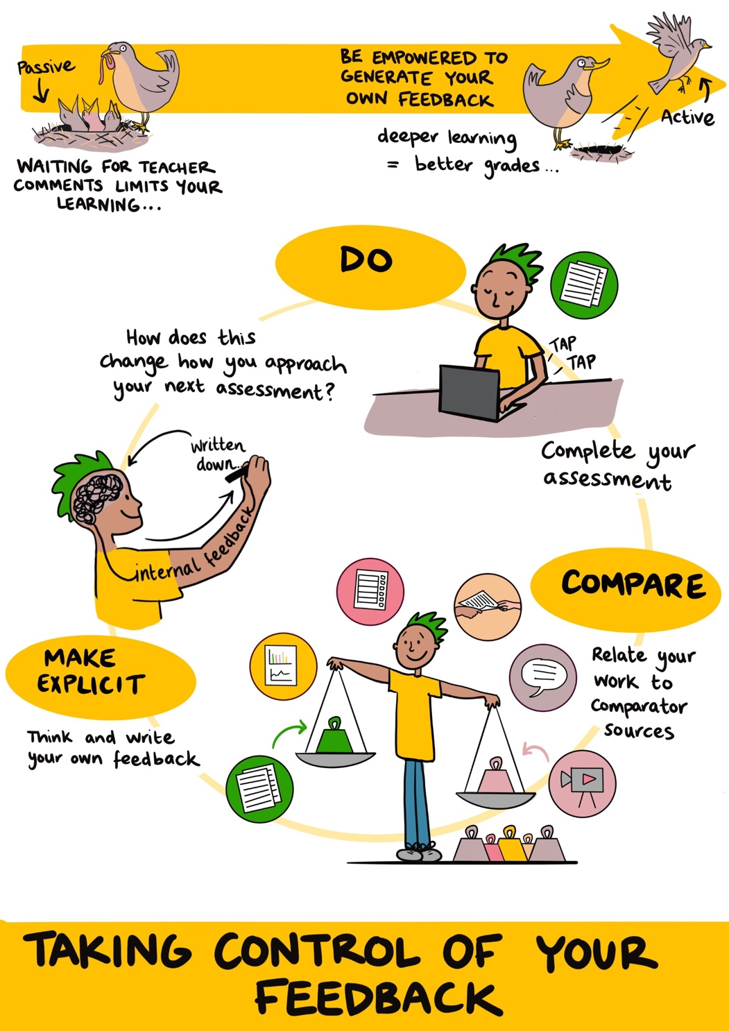
Figure 1: Active Feedback for Students (Jennifer Rose)
Do (and what to do if you get stuck)

- Always try questions on your own before looking at solutions.
  - Your problem sheets and past exam questions do test the ILOs and your understanding of the content of your course, but more importantly, they are an opportunity to practise your problem-solving and mathematical writing skills.
  - They will often encourage you to think deeply about the topic and apply what content you have learned to new problems.
  - The availability of problems that you can use to practise these skills will decrease as you progress in your degree, so you should always make the most of them.

- If you can’t do a question straight away, spend some time (at least 5-10 minutes) exploring the question.
  - Write out any relevant definitions and theorems from the course, reread your notes, and look for similar examples.
  - See if you can think of what the first step could be, or what the overall structure of your answer might end up looking like, even if you aren’t sure about the details.
    - For proof, what sort of proof should you use (direct, induction, contradiction, contrapositive, etc.)? Do you need to consider different cases?
    - If the question is procedural, what method should you use? Are there any steps you can make a start on?
  - You could also do some further research online or in a textbook, or ask a friend for help – but you should encourage them to help you reach the answer on your own, not just tell you.

- If, after attempting all these things, you still do not know how to answer the question, don’t panic!
  - This is normal, and will probably happen fairly often. The questions you are set are not supposed to be easy! What matters is the time you spend thinking about the question and working the problem. This is why in first year, submission of your problem sheet answers earns marks for effort and engagement, not whether your answers are correct.

- You may get the opportunity to ask questions about problems you found challenging in supervisions/tutorials.
  - If model solutions are not yet available, this may be your best opportunity to get some help and clarification from teaching staff
  - If you are stuck on a past exam question, you can also check with your lecturer/tutor/supervisor before class and they may be happy to go through the question in class or office hours

- Use model solutions when you are stuck, but only as a last resort.
  - If you are still stuck and model solutions are available, you now may want to look at them, but they will be the most useful to you if you have already tried a variety of the suggestions above.
  - At first, you might want to only take a glance at the solutions. Try just reading the first line(s) or skimming over the answer. Then, try and finish the problem or fill in the gaps yourself. Some modules may give ‘hints’ as well as model solutions, in which case you could try to use the hints to help you answer the question first.
  - Then, make sure to read through the model solution carefully and ensure that you understand every step. Consider:
    - Did you completely understand the original question, or did you have any misconceptions?
    - Were your earlier attempts on the right track? If so, what were you missing that would have enabled you to complete the question?
    - If your answer is different from the model solution, is it still a valid solution?
    - Is there a special trick that you didn’t know about? Often the ‘tricks’ used to solve a problem seem to come out of nowhere at first, but as you do more mathematics at university you may become more familiar with common tricks and able to apply them to new questions.
    - Did you have all the relevant knowledge you needed to put the answer together?
  - After looking, you might want to put the solutions away and give the question another go. This can help to reinforce your memory of the content and techniques for next time.

Compare (and what to use as a source of comparison)

- Once you have produced an answer to a question, compare your work to comparator sources. By comparing your work, you will generate feedback for yourself.
  - Practising comparison will develop your ability to critically evaluate your work, which can be especially useful in assessments.
  - You will get better at using comparators to give yourself feedback the more you practise.
  - Producing feedback for yourself, rather than being given it by others, encourages a much deeper understanding of the material as well as self-reflection of your own strengths and weaknesses

- There are a variety of sources of comparison. You will generate the most effective feedback if you are comfortable using a few different comparators. Usually, your comparator will be a different solution to the same problem, but it could be a solution to a different problem.
  - Model solutions (including worked-through solutions in videos/class). Model solutions will be the comparator which is closest to the ‘right answer’, but there are some things to be aware of:
    - Model solutions may give you only one of many (or infinite) possible answers. Just because your answer is not exactly the same as the model solution doesn’t mean that it is wrong or even any less of a good answer. Questions that ask you to give an example may have infinitely many possible examples, and those that ask for a proof may have multiple different equally correct proof pathways.
    - Model solutions may have more or less detail than you are expected to provide. Some model solutions may skip some steps and leave them to you to fill in, or (this is increasingly likely as you take more advanced courses). Other model solutions may try to explain every detail of a problem, so have many extraneous steps and explanations which are not expected from your answer.
    - Don’t forget, model solutions can contain typos and mistakes, so remain critical.
    - Finally, not every problem you attempt (in a problem sheet or a past paper) will have model solutions available, so you should ensure that you are not dependent on them.
  - Peers’ solutions
    - Discussion and comparison with your peers’ work is one of the most valuable resources available to you
    - Your peers’ work may contain mistakes (sometimes mistakes that you have made as well) so remain critical in your comparison
  - Solutions found online
  - AI-generated solutions (such as by ChatGPT)

- Your comparator does not necessarily need to be a perfect solution. As part of the comparison process, you must critically evaluate your comparators and remain aware of their possible shortfalls, as all have the potential to be misleading or unreliable in some way.
  - Model solutions may have typos or skip steps.
  - Your peers’ answers and online sources may contain mistakes and may contain the same mistakes as your work, making them difficult to catch.
  - The most risky source is AI, as it is not ‘mathematically intelligent’, but a predictive language model. Particularly with more complex mathematics, it is likely to get the finer points of definitions wrong, produce logically invalid and contradictory arguments, be insensitive to the context of a question, or make mathematically incorrect claims.
  - As long as you remain aware and critical of your comparators, all of these can be powerful and helpful tools.

Make explicit your comparisons

Once you have compared your solution to something else, you might have a general idea of which answer is “better”. To generate effective and specific feedback, you should ask yourself comparative questions about the two pieces of work to get to the root of why one answer is better than another. You might want to develop your own comparative questions, especially questions which are specific to the topic/question type. Here are some suggestions of questions you could use to compare solutions:
- Is one answer more clear or easier to understand than the other?
- Are both answers equally mathematically correct, or does one or both contain any mistakes?
- What differences are there between the notation used by each answer, and is one better than the other?
- Is one solution more “elegant” than the other? What exactly is it that constitutes mathematical elegance?
- Which answer is the most efficient? (i.e. has the fewest extra details or unnecessary complications)
- Does one answer depend on more complex theorems or definitions? How does this impact the overall quality of the answer?
- Does one answer have a better logical argument? If both are equally logically valid, does one answer have a logical argument that is easier to follow than the other?
- Has your solution completely answered the question? Has the comparator’s?
- Overall, summarise the main differences between your answer and the comparator. Do these differences make your answer better or worse than the comparator, or are the solutions different but good in different ways?
- Which elements from each answer would you add to the other to write the best possible answer?
- What feedback can you take away from this exercise for next time?

We suggest that you write down your answers to these questions and make your feedback explicit, at least at first, especially while you are getting familiar with this method of active feedback. This will help you to understand and internalise exactly what it is which makes one solution better than another, which in turn will help you improve for next time.

That being said, you can use this framework in whatever way you feel works best for you. You could discuss your comparisons with a friend, run through comparative questions in your head when reflecting on your work, or even discuss your comparisons with your lecturer, supervisor or tutor during class or office hours.

Finally, throughout this process remain mindful of your academic integrity. Collaboration, comparison and use of online resources are incredibly useful, but assessments should always be completed on your own unless stated otherwise.

Section 4: How to make the most of office hours

Office hours are a dedicated weekly timeslot where your lecturer will be available to discuss the course, help your understanding, and answer questions. The details of office hours and how they are used may differ slightly between courses and how your lecturer chooses to use them, so take note of any information you are given about office hours.

Office hours usually happen weekly, but you can go as often or as little as you need. You are welcome to attend as and when the need arises, which may be as little as once or twice a year or as often as several times a month.

Going to office hours can be nerve-wracking, especially if you do not know your lecturer very well. Here are some common student concerns about office hours, and how to overcome them:
- If you are nervous or put off by the intensity of a one-on-one conversation with your lecturer, you could go in a pair or small group with a couple of your peers. This can be particularly useful if you have already discussed the problem or topic with some of your peers and your group is still struggling, as you can go to office hours to seek clarification together.
- You might be worried about asking silly questions or looking stupid. First of all, remember that your lecturers are there to help you learn and do not expect you to understand everything straight away. As long as you have prepared by familiarising yourself with the resources already provided for you (lecture notes, videos, etc.), your lecturer will not judge you for not understanding something and will be happy to help. Finally, remember that all assessments are marked anonymously, so discussion during office hours cannot impact your grade outcome.
- Going to office hours can be logistically difficult, whether because of a clash, an already busy schedule, or simply the effort and organisation required to be at a specific place at a specific time. If you would like to go to office hours, you could write them into your weekly timetable so you can easily remember when and where they are happening. Lots of lecturers will also offer a Zoom alternative during their office hours, so you do not necessarily have to be on campus.
- Many students are worried about wasting their lecturers’ time during office hours. Remember that office hours are a timeslot that lecturers dedicate to helping students. If you feel that a discussion during office hours will aid your learning in any way, then attending office hours is in no way a waste of anyone’s time. Your lecturers would much rather speak to you in their office hours, even for a trivial issue, than see you struggle in silence.
- Some students who use English as a second language may be concerned about being in a conversational setting or not be very confident discussing English. Your lecturers are used to communicating with international students and will be happy to work with you in whatever way is comfortable for you, whether you would like to use any assistive technology or bring a friend to help you. Furthermore, while you will be assessed on your ability to use language correctly to communicate mathematical ideas, you will not be assessed or judged during office hours. Instead, office hours could be a great opportunity to improve your spoken English and get specific feedback about your written English communication.
- At the end of the day, it is normal to have anxiety about what can be an intense and intimidating situation, for whatever reason. You are always welcome at office hours no matter what, but it may not always be the right environment for you. In that case, make sure that when you are struggling or need some support, you seek help through at least one of the communication channels mentioned above: this might be via Piazza, email, or any other method which suits you.

One of the best ways to make the most of office hours is to come prepared with a list of questions or topics you would like to discuss. Making sure that you already know what you do and don’t understand can ensure that you and your lecturer can address any issues quickly and use both of your time efficiently.

Some example questions you might want to prepare before office hours are:
- I don’t completely understand the difference between simple and strong induction, in particular when it would be appropriate to use each method of proof. Can you take me through some examples of when each method should be used?
- I don’t understand why the solution to [a particular question] is [model solution]. Can you help me to understand why this solution works?
- Can you give me some further feedback on this piece of work (perhaps in addition to written/supervision feedback)?
- Can you help me understand why my answer to [a particular question] is wrong, or what I need to do to improve it?
- I understand [a definition or theorem] in theory, but I am not sure how to apply it. Can we go through some examples of how to apply this theory?
- I understand [a particular concept] in theory, but I am struggling to understand it intuitively or in context. Is there a different way you can explain this topic that might help me gain a more intuitive understanding?

Further resources

If you have any further questions or would like more information, there are lots of useful resources and links on the Maths UG Student Intranet, which can be found on Blackboard. The Maths UG Handbook, which can be found on the intranet but is also usually distributed via email every year, also contains lots of useful information and further links to support.

Welfare

We understand that feedback, and more generally studying at university, can at times have a negative impact on your mental wellbeing. If you are struggling, do not hesitate to reach out for help. Your tutors and lecturers will always be happy to support you with any issues within their module, and your academic advisor is a good point of contact to either provide direct help with whatever you are struggling with or otherwise to direct you towards the right places to seek support.

The Maths Welfare team are there to help with any concerns you might have and can be reached at:
maths.welfare@manchester.ac.uk

University wide resources for welfare and support can be found at: https://www.studentsupport.manchester.ac.uk/

Academic Malpractice

Throughout this guidance we have emphasised the importance of collaboration with peers to support your learning, but you must always be careful to avoid academic malpractice through collusion. Further information about academic malpractice and collusion can be found at: https://documents.manchester.ac.uk/display.aspx?DocID=639

